Installing the ConfigEditor:

Download the .zip file from the community tools page.

Unzip the file to C:\Program Files (x86)\Kronos\Apps

If this folder does not exist, you may have to create it manually.

Once unzipped go to: C:\Program Files (x86)\Kronos\Apps\ConfigEditor

Double Click on the ConfigEditor Shortcut

(You can also right click and click pin to start to add this to your start up menu programs list, or you can copy the shortcut to your desktop to be used there.)

You are now in the ConfigEditor, please click on the logo to access the in-app guide.

PCD Editor by Marcel Rottmann <marcel.rottmann@kronos.com>

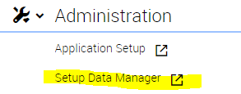To use the PCD Editor follow these steps:

1. Download one or more PCDs from Workforce Dimensions via Setup Data Manager

* 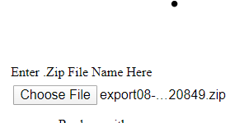**Pro Tip:** If you also download the Paycodes as well as part of your export, you can later reuse these in the add/remove Paycode features.

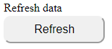2. Save the downloaded file and choose the .zip file in the UI.

4. Click the Refresh Data from File button

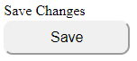5. If using more than one rule, now click into the Name of Rule Dropdown to choose your rule. Then click the Refresh button again.

6. Make any changes you need to make, when you want to save the changes, click save changes.

* When you save, you are storing a copy of your changes locally, these changes will be lost when you exit the UI.
* 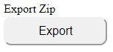**Pro Tip:** When making a lot of changes, you can also make any changes in Excel and then copy the changes back into the tool, this is best practice as any saved changes cannot be undone via Ctrl-Z.

7. Once you have made all your changes click the Export Zip File button and save the generated file when prompted.

9. Reimport your .zip file into Dimensions 😊

**Additional Features Guide:**

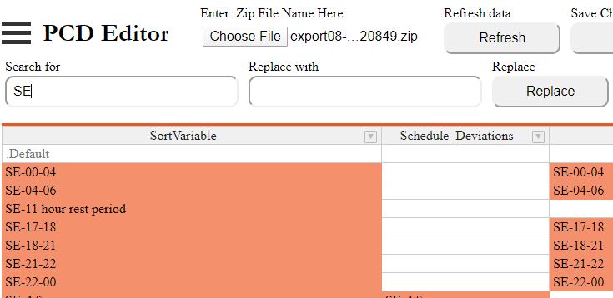1.Search and Replace.

* When you start typing into the search bar, you will see a selection highlighted.
* Once you are happy with your selection, enter a replace with value and click the replace button.
* This may take some time depending on the size of your PCD, don’t try and click other stuff in the meantime.
* You will see all the changes populate at once at the end of the process.

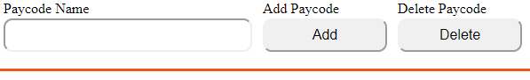2.Add and Remove Paycodes.

* 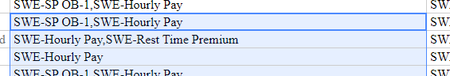If you provided Paycodes in your chosen zip, you will see a drop down of Paycodes in the Paycodes name field. Otherwise you will just see an empty field.
* You can enter a Paycode name in this column and then select a selection of cells, once you have selected the cells you want to edit either click the add or the remove button.
* Again this may take some time, just let it do its thing. For best performance with very large PCDs, you are better off handling one column at a time.

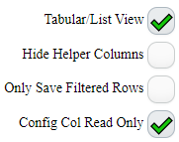3.Tickboxes

* Unticking Tabular/list view changes the way the PCD is displayed into a list view, with rows for OT instead of columns.
* Ticking Hide Helper Columns hides the columns that split out the 1st column into Deviations, Zones and RBS Rules
* Ticking only save filtered rows, will allow you to empty portions of your PCD, it will only save the cells that you have filtered.
* Unticking Config Col Read Only will let you edit the helper columns, which will in turn save changes to Zones etc. This is an advanced feature, so please use with caution. Disabling this also allows you to use Search and Replace on the those columns.

Pay Code Editor by Marcel Rottmann <marcel.rottmann@kronos.com>

To use the Pay Code Editor follow these steps:

1. Download one or more Pay Codes from Workforce Dimensions via Setup Data Manager

2. Save the downloaded file and choose the .zip file in the UI.

4. Click the Refresh Data from File button

5.Make any changes you would like to make, ensuring that each row (apart from the last) always has a Name, and that all the columns are filled out.

* You can add lines,

6. Make any changes you need to make, when you want to save the changes, click save changes.

* When you save, you are storing a copy of your changes locally, these changes will be lost when you exit the UI.
* **Pro Tip:** When making a lot of changes, you can also make any changes in Excel and then copy the changes back into the tool, this is best practice as any saved changes cannot be undone via Ctrl-Z.

7. Once you have made all your changes click the Export Zip File button and save the generated file when prompted.

9. Reimport your .zip file into Dimensions 😊

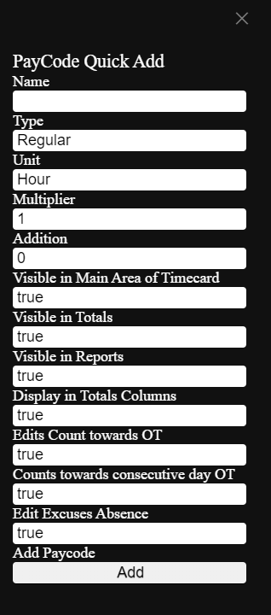**Additional Features Guide:**

1.Add Paycode

* Clicking the add paycode button opens up the add paycode slider:
* It provides a quick way to add paycodes similar to the UI with options ticked as recommended for an absence type.
* You can change any values you like and click add.

2. Tickboxes

* 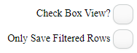Ticking Checkbox View, turns all true/false cells into checkboxes you can check/uncheck with the space bar.
* Ticking only save filtered rows will allow you only to reupload those Paycodes you have filtered into Dimensions.

Adjustment Rule Editor by Marcel Rottmann <marcel.rottmann@kronos.com>

To use the Adjustment Rule Editor follow these steps:

1. Download one or more Adjustment Rules from Workforce Dimensions via Setup Data Manager, or a number of adjustment rules from Paragon Transfer Manager from WFC.

2. Save the downloaded file and choose the .zip file in the UI.

4. Click the Refresh Data from File button

5.Make any changes you would like to make, ensuring that each row (apart from the last) always has a Name, and that all the columns are filled out.

* You can add lines, edit lines and remove and add and Remove Paycodes.

6. Make any changes you need to make, when you want to save the changes, click save changes.

* When you save, you are storing a copy of your changes locally, these changes will be lost when you exit the UI.
* **Pro Tip:** When making a lot of changes, you can also make any changes in Excel and then copy the changes back into the tool, this is best practice as any saved changes cannot be undone via Ctrl-Z.

7. Once you have made all your changes click the Export Zip File button and save the generated file when prompted.

8. Import your .zip file into Dimensions 😊

**Additional Features Guide:**

1.Search

* When you start typing into the search bar, you will see a selection highlighted.

2.Add and Remove Paycodes.

* If you provided Paycodes in your chosen zip, you will see a drop down of Paycodes in the Paycodes name field. Otherwise you will just see an empty field.
* You can enter a Paycode name in this column and then select a selection of cells, once you have selected the cells you want to edit either click the add or the remove button.

2. Tickboxes

* Ticking only save filtered rows will allow you only to reupload those Paycodes you have filtered into Dimensions.

Work Rule Editor by Marcel Rottmann <marcel.rottmann@kronos.com>

To use the Work Rule Editor follow these steps:

1. Download one or more Work Rules from Workforce Dimensions via Setup Data Manager, or a number of Work rules from Paragon Transfer Manager from WFC.

2. Save the downloaded file and choose the .zip file in the UI.

4. Click the Refresh Data from File button

5.Make any changes you would like to make, ensuring that each row always has a Name and Date as a minimum , and that all the columns are filled out in the manner they should be. You can leave cells empty to pass no rule.

* You can add lines, if you do so, make sure if you are copying a line, that you give it a new effective date.
* You can remove lines, essentially removing an effective dated rule.

6. Make any changes you need to make, when you want to save the changes, click save changes.

* When you save, you are storing a copy of your changes locally, these changes will be lost when you exit the UI.
* **Pro Tip:** When making a lot of changes, you can also make any changes in Excel and then copy the changes back into the tool, this is best practice as any saved changes cannot be undone via Ctrl-Z.

7. Once you have made all your changes click the Export Zip File button and save the generated file when prompted.

8. Import your .zip file into Dimensions 😊

**Additional Features Guide:**

1.Search

* When you start typing into the search bar, you will see a selection highlighted.

2.Add and Remove Rules.

* You can enter a Rule name in this column and then select a selection of cells, once you have selected the cells you want to edit either click the add or the remove button.

2. Tickboxes

* Ticking only save filtered rows will allow you only to reupload those Work Rules you have filtered into Dimensions.

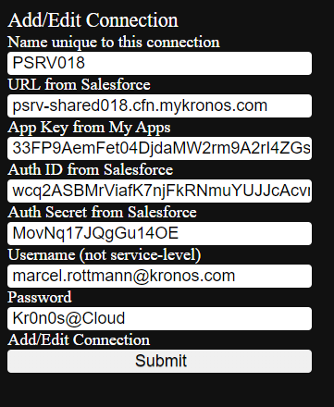Request Manager by Marcel Rottmann <marcel.rottmann@kronos.com>

To use the Request Manager follow these steps:

1. If this is your first time using the request manager, click Add Connection. Otherwise you can proceed directly to step 2.

* 1. Add in all of the details you are prompted for and ensure you have entered a memorable name. Then click Submit.

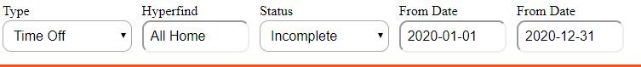2.Ensure that your query parameters are correct: As below.

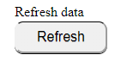

2. Click the Refresh Data button

4. Choose any actions you would like to perform in the approve? Column, an in cell drop down will provide you with correct values.

5. Make any changes you need to make, when you want to save the changes, click save changes.

**Note:** Be advised that it is starting all of the requests (and not waiting for them to finish individually), you will see the cell change from in progress to either a fail or a success when the request completes. In this time you can make additional changes and save them.

6. To check your changes have gone through, change the Status drop down to Complete. You will see all of the completed requests.

**Additional Features Guide:**

1.Search

* When you start typing into the search bar, you will see a selection highlighted.
* cells, once you have selected the cells you want to edit either click the add or the remove button.

Business Structure by Marcel Rottmann <marcel.rottmann@kronos.com>

To use the Business Structure Extracter follow these steps:

1. If this is your first time using the Business Structure Extracter, click Add Connection. Otherwise you can proceed directly to step 2.

* 1. Add in all of the details you are prompted for and ensure you have entered a memorable name. Then click Submit.

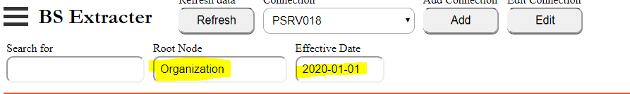 2.Ensure that your query parameters are correct: As below.



2. Click the Refresh Data button

**Additional Features Guide:**

1.Search

* When you start typing into the search bar, you will see a selection highlighted.
* cells, once you have selected the cells you want to edit either click the add or the remove button.

Person Data by Marcel Rottmann <marcel.rottmann@kronos.com>

To use the Person Data Extracter follow these steps:

1. If this is your first time using the Person Data Extracter, click Add Connection. Otherwise you can proceed directly to step 2.

* 1. Add in all of the details you are prompted for and ensure you have entered a memorable name. Then click Submit.

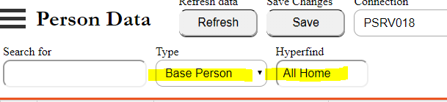 2.Ensure that your query parameters are correct: As below.



2. Click the Refresh Data button

**Additional Features Guide:**

1.Search

* When you start typing into the search bar, you will see a selection highlighted.
* cells, once you have selected the cells you want to edit either click the add or the remove button.

LC Entry Lists by Marcel Rottmann <marcel.rottmann@kronos.com>

To use the LC Entry Lists follow these steps:

1. Download one or more LC Entry Lists from Workforce Dimensions via Setup Data Manager, or a number of Work rules from Paragon Transfer Manager from WFC.

2. Save the downloaded file and choose the .zip file in the UI.

4. Click the Refresh Data from File button

5.Make any changes you would like to make sure that all the columns are filled out in the manner they should be. You can leave cells empty to pass no rule.

* You can add lines, if you do so, make sure if you are copying a line, that you give it a new effective date.
* You can remove lines, essentially removing an effective dated rule.

6. Make any changes you need to make, when you want to save the changes, click save changes.

* When you save, you are storing a copy of your changes locally, these changes will be lost when you exit the UI.
* **Pro Tip:** When making a lot of changes, you can also make any changes in Excel and then copy the changes back into the tool, this is best practice as any saved changes cannot be undone via Ctrl-Z.

7. Once you have made all your changes click the Export Zip File button and save the generated file when prompted.

8. Import your .zip file into Dimensions 😊

**Additional Features Guide:**

1.Search

* When you start typing into the search bar, you will see a selection highlighted.

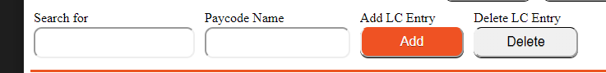 2.Add and Remove Rules.

* You can enter a Rule name in this column and then select a selection of cells, once you have selected the cells you want to edit either click the add or the remove button.

Holiday Profiles by Marcel Rottmann <marcel.rottmann@kronos.com>

To use the Holiday Profiles Editor follow these steps:

1. Download one or more Holiday Profiles from Workforce Dimensions via Setup Data Manager.

2. Save the downloaded file and choose the .zip file in the UI.

4. Click the Refresh Data from File button

5.Make any changes you would like to make sure that all the columns are filled out in the manner they should be. You can leave cells empty to pass no rule.

* You can add lines, if you do so, make sure if you are copying a line, that you give it a new effective date.
* You can remove lines, essentially removing an effective dated rule.

6. Make any changes you need to make, when you want to save the changes, click save changes.

* When you save, you are storing a copy of your changes locally, these changes will be lost when you exit the UI.
* **Pro Tip:** When making a lot of changes, you can also make any changes in Excel and then copy the changes back into the tool, this is best practice as any saved changes cannot be undone via Ctrl-Z.

7. Once you have made all your changes click the Export Zip File button and save the generated file when prompted.

8. Import your .zip file into Dimensions 😊

**Additional Features Guide:**

1.Search

* When you start typing into the search bar, you will see a selection highlighted.

Detail to Dataview by Marcel Rottmann <marcel.rottmann@kronos.com>

To use the Detail Genie Migrator follow these steps:

1. If this is your first time using the APIs in the ConfigEditor, click Add Connection. Otherwise you can proceed directly to step 2.

* 1. Add in all of the details you are prompted for and ensure you have entered a memorable name. Then click Submit.

1. Download one or more Holiday Profiles from Workforce Dimensions via Setup Data Manager.
2.  Save the downloaded file and choose the .zip file in the UI.
3.  Click the Refresh Data from File button
4. Make any changes to any columns which are not greyed out that you wish, but you can just proceed to the next step.
5. Click Upload, to upload your data to the tenant selected in the connection drop down.

**Additional Features Guide:**

1.Search

* When you start typing into the search bar, you will see a selection highlighted.
* cells, once you have selected the cells you want to edit either click the add or the remove button.